Оставшиеся задания со второго урока

-- d) Найти самый минимальный вес и самый максимальный размер продукта для каждой подкатегории ProductSubcategoryID из Production.Product.

SELECT ProductSubcategoryID, MIN([Size]) AS Min_Size, MAX([Size]) AS Max_Size
FROM AdventureWorks2017.Production.Product
GROUP BY ProductSubcategoryID
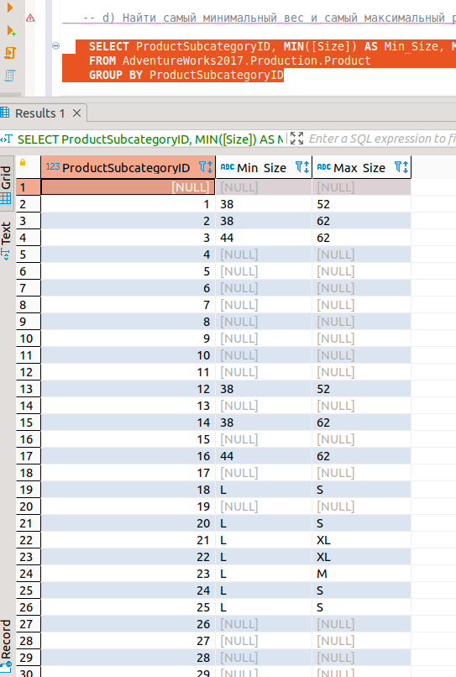

--e) Найти самый минимальный вес и самый максимальный размер продукта для каждой подкатегории ProductSubcategoryID из Production.Product,
--где цвет продукта определен(Color).

SELECT ProductSubcategoryID, MIN(Weight) AS Min_Weight, MAX([Size]) AS Max_Size
FROM AdventureWorks2017.Production.Product
WHERE Color = 'Black'
GROUP BY ProductSubcategoryID
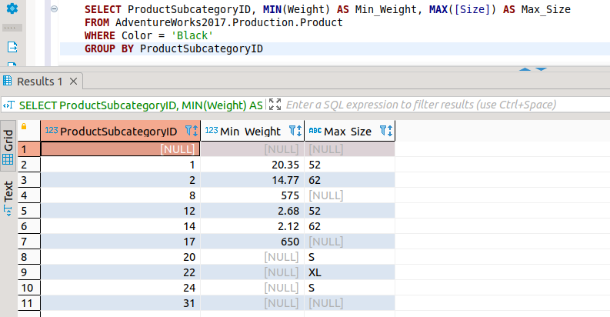

ЗАДАНИЯ 3 УРОКА
2а

SELECT DISTINCT Name,
CASE WHEN StandardCost = 0 OR StandardCost IS NULL THEN 'Not for sale'
WHEN StandardCost > 0 AND StandardCost < 100 THEN '<$100'
WHEN StandardCost >=100 AND StandardCost < 500 THEN '<$500'
ELSE '>=$500'
END AS PriceRange
FROM AdventureWorks2017.Production.Product
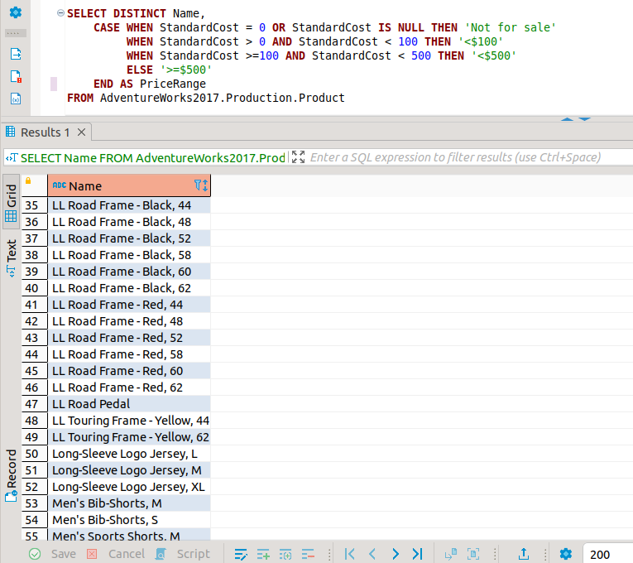

2b.
SELECT ProductID, PV.BusinessEntityID, Name
FROM AdventureWorks2017.Purchasing.ProductVendor PV FULL JOIN AdventureWorks2017.Purchasing.Vendor P ON PV.BusinessEntityID=P.BusinessEntityID
WHERE StandardPrice > 10 AND (Name LIKE '%X%' OR Name LIKE 'N%')

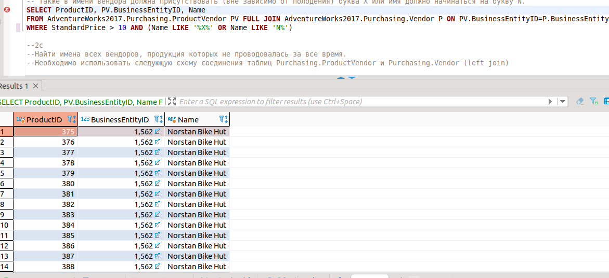

2с
SELECT V.Name
FROM AdventureWorks2017.Purchasing.Vendor V
LEFT JOIN AdventureWorks2017.Purchasing.ProductVendor PV ON V.BusinessEntityID=PV.BusinessEntityID
WHERE PV.BusinessEntityID IS NULL

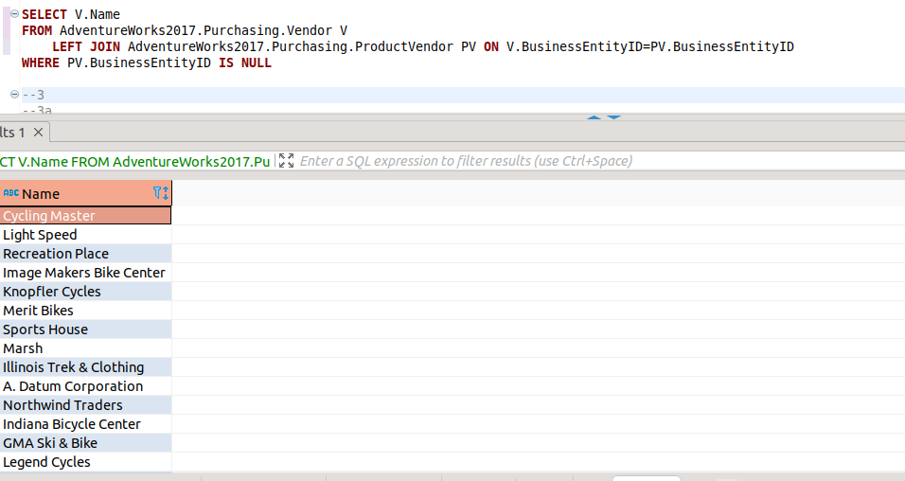

3a
SELECT P.Name, StandardCost
FROM AdventureWorks2017.Production.Product P LEFT JOIN AdventureWorks2017.Production.ProductModel PM ON P.Name=PM.Name
WHERE P.Name LIKE 'LL%'
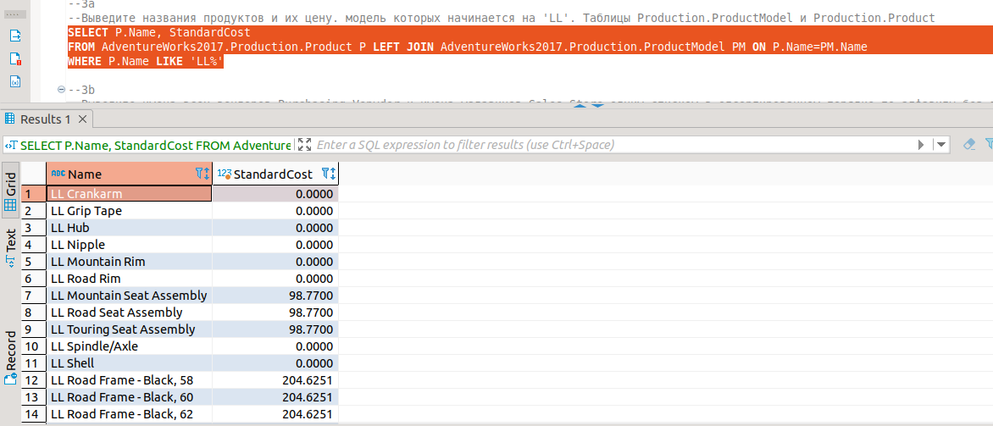

3b
SELECT Name
FROM AdventureWorks2017.Purchasing.Vendor
UNION
SELECT Name
FROM AdventureWorks2017.Sales.Store
ORDER BY Name

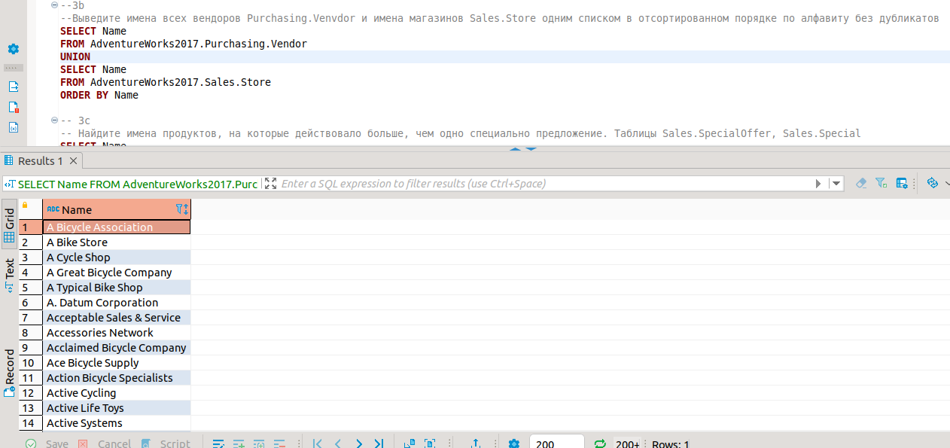

3с
SELECT Name
FROM AdventureWorks2017.Production.Product PP
LEFT JOIN AdventureWorks2017.Sales.SpecialOfferProduct SOP
ON PP.ProductID=SOP.ProductID
LEFT JOIN AdventureWorks2017.Sales.SpecialOffer SO
ON SOP.SpecialOfferID=SO.SpecialOfferID
GROUP BY Name
HAVING COUNT (SO.SpecialOfferID) > 1

